Opetussuunnitelman yleinen osa

EI18SP Degree Programme in Mechanical Engineering 2018

Sisällys
1 Basis of Education 2
2 Competence Standards 2
3 Structure of Studies 6
4 Development of Expertise 7
5 Methods and implementation 9

1 Basis of Education
The degree title is Bachelor of Engineering in Mechanical Engineering. The title of the degree in Finnish is called konetekniikan insinööri (AMK). The study programme is 240 ECTS and the full- time studies take about 4 years. The studies take place in Kuopio and they are conducted in English. This programme qualifies to apply for master degree programmes.
The degree programme of Mechanical Engineering qualifies the future engineers for the various tasks in the technology industry. Duties vary within the fields of engineering, business and management such as project management, sales engineering, operations and supply chain management and engineering. The future job is most probably found in a company operating with global exports.
The technological expertise learned in the programme includes product design and development, and manufacturing technology. The studies in production and business management concentrate on project management, marketing, sales, business economics, procurement, supply chain, international business operations and quality management.
An important part of the programme is getting familiar with operating effectively in a variety of interpersonal networks. Self-development, communication and interpersonal skills, organizational and social as well as international competences and problem-solving skills are included in the engineering know-how. The objective of the programme is to produce a high-quality team player instead of an individual player.
The structure of the studies is based on process thinking and the learning process is based on problem based learning. Students are able to include in their programme special project studies in companies in Finland or abroad.

2 Competence Standards
The qualification of a Bachelor of Mechanical Engineering is at the European and Finnish level 6.
(The national framework of qualifications and other learning).

Competence Area | Competence at level 6
Knowledge | A Bachelor of (Mechanical) Engineering possesses comprehensive and advanced knowledge of the mechanical engineering including the critical and analytical understanding of theories, methods and principles. He/she understands the extent and boundaries of the professionals task in the technical field.
Skills and Application | A Bachelor of (Mechanical) Engineering processes advanced skills, which demonstrate mastery of the field and capacity to apply knowledge and to find creative solutions for complex or unpredictable problems in the engineering field.
Responsibility, Management and Entrepreneurship | A Bachelor of (Mechanical) Engineering processes the capability to manage projects or complex professional activities and is able to work independently in expert positions in the engineering field. He/she is able to make decisions in unpredictable operational environments and possesses the basic skills and knowledge for working as a entrepreneur in the field.
Evaluation | A Bachelor of (Mechanical) Engineering processes the capability to take responsibility for the evaluation and development oh his/her competence as well as other individuals and groups.
Self-development and Lifelong Learning | A Bachelor of (Mechanical) Engineering processes the capability for continuous learning. He/she knows how to communicate effectively both orally and writing to audiences representing the engineering field as well as other audiences. He/she is able to interact and communicate independently in an international environment.

Generic competences | Description of the competence
Learning competence | The Bachelor of (Mechanical) Engineering  - possesses the capability to evaluate and develop his/her competences and learning style  - possesses the capability to retrieve and analyze information and evaluate it critically  - is able to take responsibility for collaborative learning and sharing knowledge in teams  - possesses the capability of combining an entrepreneurship-focused way of action with his/her professional deepment and career planning
Ethical competence | - is able to take responsibility for his/ her actions and their consequences  - possesses the capability of following the ethical code of conduct in his/her professional field  - possesses the capability of taking into account other people  - is able to follow the pronciples of equality  - is able to apply the principle of sustainability to his/ her field  - is able to interact in the society using his/her skills and knowledge in accordance with ethical values
Working community competence | - is capable of acting as a member of a work community  - possess the capability to interact and communicate in various situations in the working life  - is able to utilize information technology and communication technology in tasks of his/her field  - is capable of networking and making personal contacts in the working life environment  - possesses the capability to make decisions in unpredictable situations  - is able to work independently to complete tasks which require profes-sional expertise  - possesses the skills and the knowledge to work as an entrepreneur
Innovation competence | - possesses the skills and the knowledge for creative problem solving and is able to further develop the working methods  - is capable of working in projects  - is able to implement research and development projects by applying prior knowledge and methods in the field  - is able to look for customer-oriented, sustainable and economically profitable solutions
International competence | - possesses the language skills necessary for his/her work and profes-sional development  - is able to co-operate in a multicultural environment  - is able to take into account of the influence and the opportunities of internationalism in his/her work
Specific competences of a Mechanical Engineering | Description of the competence
Basic competencies of mechanical engineering | - Is able to apply mathematical methods and tools to describe the phe-nomena of the field and to solve problems  - Is familiar with the essential physical laws used in the technical applications, especially regarding the field of mechanical engineering  - Is familiar with the mechanical components and understands their functions  - Knows the basic measurements and materials of mechanical engineering, as well as masters the basics of technical drawing and design
Product development | - Knows the methods and tools of product development  - Is able to dimension and select machines and components using techno-economic principles  - Is able to produce standardised documentation  - Is familiar with the quality system of products and production  - Understands the product life cycle
Manufacturing
  - Knows the typical/popular manufacturing systems
  - Gets familiar with the most used materials in mechanical engineering, especially steels
  - Gains insight into quality management processes
  - Understands the quality and development in engineer's practical work
  - Is able to use quality tools
Business and Production Management | - Knows the prerequisites of profitable business and the most important tools of economical design and direction  - Has the skills needed to take part in project work and to manage peo-ple, processes and projects  - Is familiar with the basic principles of entrepreneurship, marketing and service

3 Structure of Studies
The studies for a Bachelor’s Degree in Mechanical Engineering comprise 240 ECTS. According to the curriculun, the work load for one academic year is 60 ECTS which is approximately 1600 hours of student’s work. It consist, among others, of contact lessons in class, distance and inde-pendent learning, e-learning, project working and practical training. R&D activities are included in the studies.
Type of studies | Extent | Description of studies
Basic Studies | 60 ECTS | Basic studies consist of compulsory courses that provide the student with a solid foundation for mechanical engineering and guide him/her to business and economic thinking in a multicultural environment. In addition, the studies give essential skills needed for personal learning, career planning and professional studies.
Professional  Studies | 60 ECTS | Professional studies provide students with a good knowledge of industrial processes and engineer's basic competences in mechanical engineering, production and logistics. These studies provide students also with a good knowledge and understanding of business processes and business life in society.
Specialisation Studies | 60 ECTS | Specialised studies deepen students' theoretical understanding and practical skills in an engineer's work and make students learn to apply theories into practical cases. Student’s get professional skills in manufacturing and operations, business and project management and integrated product planning. Studies consist also projects.
Internship | 30 ECTS | The aim of the internship is to introduce the student to the practical work assignments and to the choice and use of different working methods, as well as to the application of knowledge and skills in the situations of the working life. The student learns to improve the quality of his/her tasks and to create new problem solving methods in a customer-oriented way. The internship prepares the student for the working life as it deepens his/her professional competence, skills and knowledge, and enhances his/her employment opportunities.
Thesis | 15 ECTS | The thesis is a working life oriented learning process for the student as it is supervised, guided and evaluated by professionals. The aim of the thesis is to improve the viability of the client and at the same time to deepen the professional skills and knowledge of the student in the chosen subject. A thesis can be practical or research-based or it can involve a subjective expression of a creative assignment. In the thesis process the student is responsible  - for finding a thesis topic integrated with working life  - increasing his/her knowledge of the subject field and creating the framework for the assignment  - carrying out the assignment and reporting on the process and outcomes  - finalizing the thesis and drafting information material.  The thesis offers a flexible way of entering the working life and a good opportunity for networking.
Elective Studies | 15 ECTS | Elective studies support the development of the student’s professional skills and expertise and are chosen according to his/her interests in the focus areas of the degree programme. The student can also choose to take courses that are arranged by other faculties of Savonia UAS or other schools and universities. Studies carried out elsewhere have to correspond to the level of studies in higher education.
Total | 240 ECTS

4 Development of Expertise
The curriculum has been planned so that the degree programme provides the student with the knowledge, skills and competence required in the working life and the studies ensure the development of the student’s professional expertise.
Each student starts planning his/her career path already during the first study year as he/she drafts an individual study plan. This way the student takes responsibility for the progress of his/her studies. Savonia’s teachers and other personnel guide and support the student in defining and achieving the personal goals in the study plan.
Tähän uusi rakennekuva: Mechanical Engineering OPS2018 structure picture ENG

The Bachelor programme in Mechanical Engineering at Savonia UAS aims at educating future engineering experts strongwith both Mechanical Engineering as well as Production and Business Management skills. The curriculum is designed to encourage students to develop their expertise step by step; first, getting an introduction to the basics of Engineering, along with Mechanical Engineering. Later, students deepen their understanding in Mechanical Engineering and apply the gained knowledge into practice, e.g. working in projects and solving real company cases. In the specialization phase, students are introduced to Production and Business Management, i.e. Industrial Management, and are developing their expertise from know-how to show-how, in a close contact with real working life.
The annual themes for each academic year are the following:
 |  | Annual theme and subthemes |  | Competence objectives
1st year |  | Basics of Engineering, 60 ECTS  Studying the basics (30 ECTS)  Introduction to Mechanical Engineering (30 ECTS) |  | The student understands the laws of nature and can apply these for research and development work.
2st year |  | Applying Engineering Studies 60 ECTS  Developing the basic skills and know-how  in Mechanical Engineering (30 ECTS)  Applying skills and know-how in Mechanical Engineering (30 ECTS) |  | The second-year themes shift focus to the applying engineering.  During the first term of studies the student has skills for mechanics, fundamentals of strength of materials , mathematics, effective communication, etrepreneurship and practical training.  The second term continues to applying skills and know-how in mechanical engineering. Students has skills for physics for engineering, electricity, material technology, RD project and practical training.
3st year |  | Deepening the Knowledge 60 ECTS  Deepening Mechanical Engineering know-how (30 ects)  Specializing in Industrial Management (30 ects) |  | The third-year students will focus on deepening the knowledges. Students has skills for project management tools, business to business marketing, procurement and purchasing management, operations management, manufacturing technology and materials management and quality management and engineering, management accounting, industrial management project, manufacturing systems development and elective studies.
 | 4st year |  | Applying Lessons Learned 60 ECTS  Applying Industrial Management know-how (30 ECTS)  Applying the learned skills and know-how in the working life/ Show-how in the working life (30 ECTS) |  | The last-year students will focus on applying the knowledges. Students has skills for sales project control and management, execution project control and management, supply chain and network management, data management and ERP, industrial management project and final is thesis.  The graduates of Mechanical Engineering will be skilled international team players.

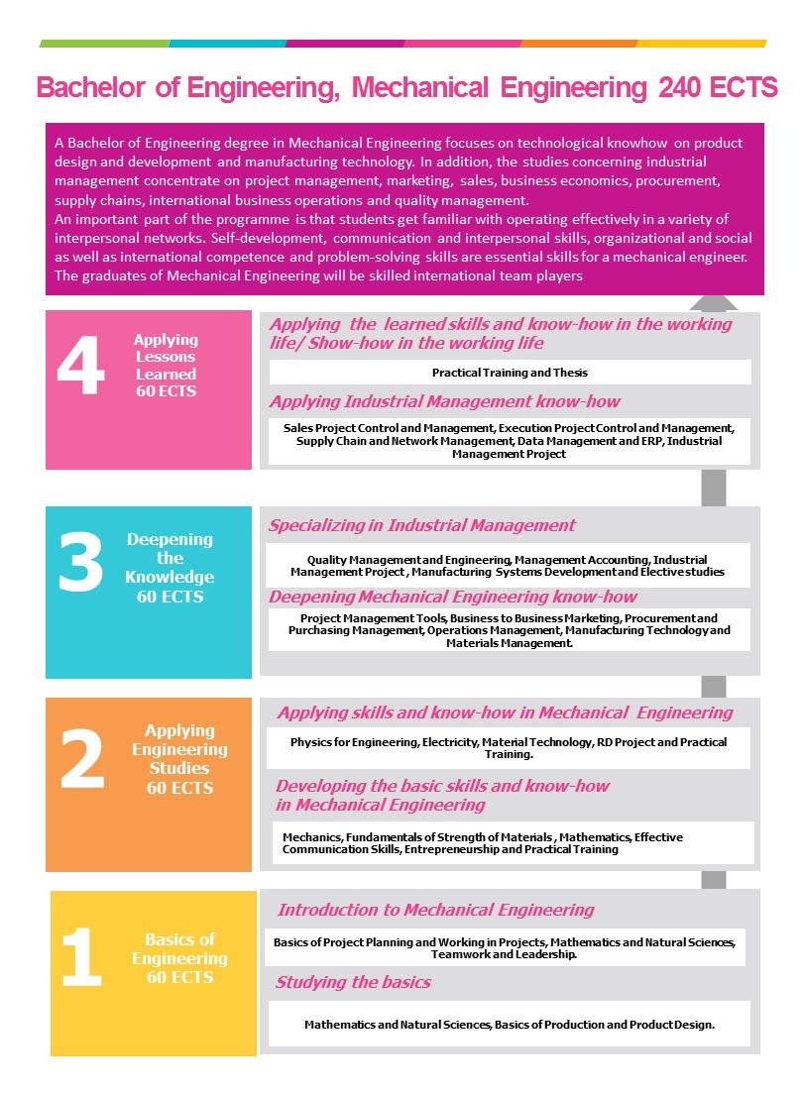

5 Methods and implementation
Savonia provides education which is guided by OIS thinking (Open Innovative Space, OIS 2.0). The objective is to combine high-quality learning and teaching with the working life oriented research and development assignments. The student is an active doer and he or she studies in different teams where students come from various fields of studies and where representatives of local business also take part. Most of the assignments are developed in co-operation with working life. Engineering studies follow closely the CDIO method (Conceive Design Implement …) which is based on project teaching. The first year students will start with an orientation project to learn the basics of project working. Second year students will carry out a multicultural and multidisciplinary RD project solving cases assigned by local companies. During the last two study years students will have Industrial Management Projects 1 and 2. The thesis can be seen as the final project that is usually carried out individually.
Close networking with local businesses, especially during project studies and practical training, guarantees that the curriculum is up-to-date and that the learning outcomes benefit both the student's career development as well as the local businesses. In addition, the studies are based on the principles of accessibility and sustainable development.
In the early stages of studies students will make their personal study plans. Most of the students follow the programme curriculum as their personal study plan. However, if a student has already studied e.g. in the engineering field earlier, then prior learning, completed degree studies and acquired competencies can often be acknowledged so that the completion time of Mechanical Engineering degree studies can be shorter, or the work load can be lighter for some academic terms. If a student is working along his/ her study path, the learning at work can be educationalized according to Savonia practices. The previous must be agreed on and planned together with Savonia counselling personnel.
Students can complete their personal study plan with 15 credits of elective studies supporting the professional know-how and skills they want to focus more. In addition, students have the benefit of an extensive international partner university network for carrying out exchange studies or practical training outside Finland. Also, a double degree option exists with Windesheim University.
The options for e-learning and summer studies are growing from year to year, and students are encouraged to choose such studies, e.g. for their elective studies. Also, apart from being able to communicate in one’s native language and English, it is recommend to study Finnish or any other foreign language to enhance the international competence even further. Swedish studies are compulsory part of the curriculum for those with a Finnish educational background.
Tähän EURACEKUVA
In 2014, the Savonia University of Applied Sciences Degree programme in Mechanical Engineering passed the EUR-ACE evaluation which is maintained by the organization of ENAEE. This is a European technology organization that evaluates programmes for engineers. The EUR-ACE status makes sure that the programme meets the quality standards of the European Union. Informally, the students graduating from a programme with this status can be called as European engineers. Graduates can work as chartered professional engineers throughout Europe.

