mASTER’S dEGREE, eNVIRONMENTAL eNGINEERING

MASTER’S DEGREE PROGRAMME ENVIROnMENTAL ENGINEERING CURRICULUM, GENERAL PART 2015

APPROVED BY: Vice President, Mr Mikko Vuoristo

Contents
BASIS OF EDUCATION 3
cOMPETENCE STANDARDS 3
STRUCTURE OF STUDIES 6
DEVELOPMENT OF EXPERTISE 8
IMPLEMENTATION 9

Basis of Education

The Master’s Degree Programme in Environmental Engineering is a 60 ECTS programme which leads to a Master’s Degree in Engineering (M. Eng.). The skills and competence gained through this programme meet the requirements of the working life in view of extensive and profound knowledge and skills in environmental engineering. It also provides the required knowledge of the field-related theory to enable the graduates to work in challenging managerial positions in the field. University of applied sciences Master’ Degree is equivalent to a university Master’s Degree and the graduates are equally eligible for public posts. The name of qualification is Master of Engineering. (The government decree on polytechnics 352/2003)

The degree programme in environmental engineering is work-oriented education primarily targeted at Bachelors of Engineering (UAS). The students can complete the degree studies either alongside work or as full-time students; the studies take 1.5-2 years.

The content and aims of the programme are based on the identified competence needs in the environmental industry. In addition, the programme is focused on the scientific, technological and business key innovation and development projects which contribute to economic reform. These projects are included in the Northern Savo regional plan. The education promotes the ’biofuels and bio refining’ fields as well as enhances the development of a new field ’The locus of water processes and air technology’ in accordance with the regional plan.

The student gains excellent project work as well as research data collection and processing skills. He or she is able to apply this data to his or her own work and its development. The aim of the studies is to promote willingness for lifelong learning, innovation, internationality and wellbeing at work.

When studying alongside work, educationalization is used extensively. The skills and competence required for completing the degree are gained through development work which meets the employer’s needs. This work supports the working student’s professional development and graduation process as well as the employer’s business development needs. The Savonia UAS specialist staff supports the educationalization and development process actively in close cooperation with the student and employer.

Competence Standards

The qualification of a Master of Engineering is at the European and Finnish level 7 (The national framework of qualifications)

Competence area | Competence at level 7
Knowledge | A Master of Engineering possesses a comprehensive and highly specialised knowledge in the field of engineering including key concepts, methods and know-how which serve as a base for independent thinking and/or research. He or she understands the issues relevant to field-specific and multi-field interfaces. He or she is able to analyse them and new information critically.
Methods&Application  (Skills) | A Master of Engineering possesses strong skills in solving challenging problems related to research and/or innovation activities through which new knowledge and methods are developed. He or she is able to apply and combine knowledge from different fields.
Responsibility, Management and Entrepreneurship | A Master of Engineering is able to work independently in challenging expert positions or as an entrepreneur in the field of environmental engineering. He or she possesses the capability to employ and develop complex, unpredictable and new strategic approaches to work. He or she also possesses good issue and/or people management skills.
Evaluation | A Master of Engineering possesses skills to evaluate the activities of both teams and individuals. He or she is also able to acquire new knowledge and find new methods and/or take responsibility for the development of other individuals.
Key Skills for Lifelong Learning | A Master of Engineering possesses the capability for continuous learning. He or she also knows how to communicate effectively both verbally and in writing with the people in the field and other audiences. He or she is able to interact and communicate effectively in an international environment in one official language and at least one other language.

The competence profile of a Master of Engineering consists of generic and specific competences.

Generic competences | Description of the competence (level 7)
Learning Competence | The student  -is capable of versatile and goal-oriented evaluation and development of his or her expertise  - is able to retrieve, process, produce information and to evaluate it critically from different perspectives  - is able to take responsibility for collaborative goal-oriented learning
Ethical Competence | - is able to take responsibility for one’s own actions and the consequences of the actions  - is able to follow the ethical code of conduct as an expert in the professional field and as an innovator  - possesses the capability to take individual and community views into account in decision-making  - is able to promote the realisation of the principles of equality in the working community  - is able to promote the realisation of sustainability and social responsibility  - is able to manage socially impactful activities in accordance with ethical values
Working Community  Competence | - is able to develop the activities in the working community and enhance wellbeing at work  - is able to develop multidisciplinary communication and interaction in the working life  - is able to utilise information technology and communication technology in his or her work  - is capable of networking and creating partnerships  - is capable of managing and reforming activities in complex and unpredictable operational environments  - is capable of working in demanding specialist duties, managerial duties or as an entrepreneur
Innovation  Competence | - is able to produce new information and reform working methods by combining the know-how in different fields  - is able to manage projects  - is able to manage research, development and innovation projects and masters research and development methods  - is able to develop customer-oriented, sustainable and economically viable operations
International  Competence | - is able to communicate in an international working environment and in operational development  - is able to work in international environments  - is able to anticipate the effects of international development in his or her professional field and consider the possibilities

Specific competences | Description of the competence (Master’s degree)
Publishing Competence | The student  - is able to conduct a mature literature survey on a given topic  - is able to write a good-quality research report in accordance with the principles of professional and scientific publications  - is able to present his or her own research and development project
Development Competence in Water Technology or Environmental Monitoring or Biotechnology | - is able to work actively and efficiently in a networked development environment  - understands the developmental role of universities of applied sciences, universities, sectoral research institutes and enterprises
Partnership Competence | - masters the operational models and understands the methods to maintain cooperation networks in the working life after studies

Structure of Studies

The Master’s Degree Programme in Environmental Engineering is 60 ECTS and the accomplishment takes 1.5-2 years. According to the curriculum one academic year of full-time studying corresponds to 60 ECTS, which is equivalent to 1600 hours of a student’s workload. The study time in the master’s programme may vary due to diverse educational backgrounds and work experience. Recognition of prior learning may shorten the study time.

The structure of the degree programme is presented in the following chart. The studies contain field-specific professional studies (20 ECTS), joint master’s studies at Savonia UAS (10 ECTS) and a thesis (30 ECTS). The student chooses at least 10 ECTS from the joint studies of the master’s programmes at Savonia UAS. They include entrepreneurship, research and development as well as management of expert organisations.
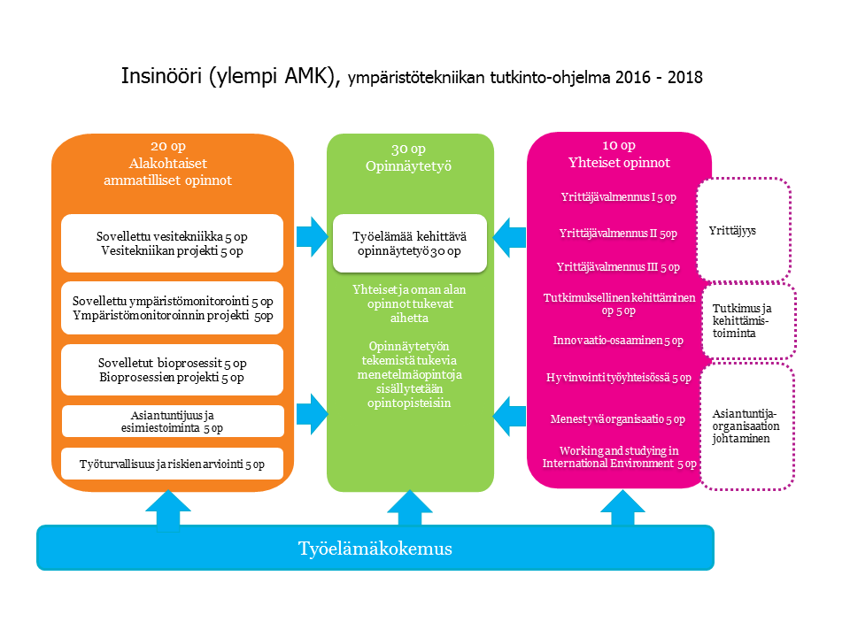
Chart 1. The Structure of Studies

The objectives, contents and methods of the courses are described in the curriculum course descriptions. The Savonia OIS project teaching methods (OIS-Open Innovation Space) guide the implementation of the studies. The studies are part of the research and development work of Savonia UAS, businesses and other partners. It is possible to use the Savilahti joint laboratory premises during the studies.

The student makes a work-oriented personal study plan for his or her studies in cooperation with the supervisor and, if needed, with the employer. In addition, the skills and learning gained earlier in the working life are recognised in accordance with the RPL system at Savonia UAS (RPL – recognition of prior learning).

The master’s thesis is an extensive, applied development or research project during which the student demonstrates his or her ability to apply research data and to produce new solutions as well as to reform work-life practices. The students start the thesis plans as early as at the beginning of the studies and the personal study plan is made to support the achievement of the goal. The course ’Inquiry Based Development’, thesis seminars and method clinics support the thesis work. One aim of the thesis work is to gain publishing competence which is an integral part of research and development work. Some of the courses are taught in the English language.

Development of Expertise

Contemporary employees move from one position to another within an organisation and between organisations. As the content of work changes, the employees’ versatile skills and reaction ability are emphasised. The multidisciplinary and international nature of work is emphasised in most fields. A successful employee needs service, business and technological skills as well as skills to promote wellbeing in the society and environment. Analytical reasoning and problem-solving skills, critical thinking and data management skills are required to be able to develop wellbeing and create innovations in the working life.

It is increasingly important to focus on a user driven and user experience approach. Lifelong learning is closely linked to an employee’s career development. The themes of competence at Savonia UAS describe the view of the competence required in the future working life. The curricula include four strategically selected common themes: lifelong learning, innovations, internationality and wellbeing at work. These themes run through the implementation plans and assessment criteria of the studies. They are in line with the national and field-specific competences which are described in the table below.

The curricula at Savonia UAS are composed of courses. They are not separate but support the development of a student’s expertise and his or her development as a whole. They also enable the combination of work-oriented research, development and innovation activities.

The Master’s Degree in Environmental Engineering is devised to
- produce the skills and competence required in the working life
- ensure the development of the student’s professional expertise

The student
- drafts his or her personal study plan to support the studies. Prior learning is recognised (includes at least 5 ECTS of studies in a foreign language)
- takes responsibility for the progress of his or her studies

The teachers and other members of staff at Savonia UAS guide and support the student in defining and achieving personal goals.

The competence profile of a Master of Engineering is built upon the knowledge and skills gained during the courses. The table below presents the courses per academic year and the competences they focus on.
Taulukko 1. Ympäristötekniikan YAMK -tutkinnon opintojaksojen kompetenssitaulukko

Implementation

The master’s environmental engineering education is based on the competence and development demands of the working life. The students’ own working life experiences contribute to the learning. Competence goal-oriented expert knowledge and practice-oriented teaching methods are used to deepen the experiences. The methods emphasise reflective thinking and sharing knowledge and know-how. The student’s role is to be an active, responsible and critical doer. He or she is able to make choices related to his or her studies on the basis of his or her personal development challenges.

The education is implemented as multiform studies including contact lessons, independent studying, eLearning, practical work and assignments. The student can study alongside with work and link his or her assignment and thesis research to the development of his or her working place. The number of days for contact lessons is approx. 2 days/month, mainly on Fridays and Saturdays in Kuopio.
International competence is enhanced in many ways. Each student must have at least 5 ECTS of studies in a foreign language included in his or her personal study plan.
The accomplishment of the student’s study goals is guided and monitored through evaluation. The whole study and learning process is evaluated. The focus is on the achieved knowledge and skills as well as on the attitude and ability to assume responsibility required in the working life. Course evaluation is based on the criteria presented in the course description.

The environmental engineering students and staff at Savonia UAS are in close, daily contact with the working life representatives. The timeliness, competitiveness and quality of the education are ensured through continuous national and international cooperation with other educational institutes, sectorial research institutes and with the business sector.

