EI16SP Degree Programme in Mechanical Engineering
https://portal.savonia.fi/amk/fi/opiskelijalle/opetussuunnitelmat/testiops?yks=KT&krtid=983&tab=1
Basis of Education
The degree title is Bachelor of Engineering in Mechanical Engineering. The title of the degree in Finnish is called konetekniikan insinööri (AMK). The extent of the study programme is 240 ECTS and the full time studies take about 4 years. The studies take place on Opistotie Campus in Kuopio. With EUR-ACE status, this programme qualifies to apply for master degree programmes in European Union.
The degree programme of Mechanical Engineering qualifies the future engineers for the technology industry. Duties vary within the fields of engineering, business and management such as project management, sales engineering, operations and supply chain management and engineering. The work placement is most probably found in a company operating with global exports.
Project operations as well as customer, contractor or partnership interactions require professional attitude and core competences in teamwork know-how, methods and tools.
The necessary technology expertise focuses on product design and development, and manufacturing technology. The studies in business management concentrate on project management, marketing, sales, business economics, procurement, supply chain, international business operations and quality management.
An important part of the programme is getting familiar with operating effectively a variety of interpersonal networks. Self-development, communication and interpersonal skills, organizational and social as well as international competences and problem-solving skills are included in engineering know-how. The objective of the programme is to produce a high-quality team player instead of an individual player.
The structure of the studies is based on process thinking and the learning process on problem based learning. Students are able to include in their programme special project studies in companies in Finland or abroad.

https://portal.savonia.fi/amk/fi/opiskelijalle/opetussuunnitelmat/testiops?yks=KT&krtid=983&tab=2
Competence Standards
The Bachelor of Engineering in Mechanical Engineering Degree Programme provides a student with unique competences including a strong base on mechanical engineering but also focusing on industrial management, and in particular, project management and networks.
In the early stages of studies students will make their personal study plans. Most of the students follow the programme curriculum as their personal study plan. If a student has already studied, e.g. in the engineering field, earlier, then prior learning, degrees and acquired competencies can often be acknowledged so that the completion time of degree studies can be shorter, or the work load can be lighter for some academic terms.
Students can complete their personal study plan with 15 credits of elective studies supporting the professional know-how and skills they want to focus more. In addition, students have the benefit of an extensive international partner university network.
In 2014, the Savonia University of Applied Sciences Degree programme in Mechanical Engineering passed the EUR-ACE evaluation which is maintained by the organization of ENAEE. This is a European technology organization that evaluates programmes for engineers. The EUR-ACE status makes sure that the programme meets the quality standards of the European Union. Informally, the students graduating from a programme with this status can be called as European engineers. Graduates can work as chartered professional engineers throughout Europe.


https://portal.savonia.fi/amk/fi/opiskelijalle/opetussuunnitelmat/testiops?yks=KT&krtid=983&tab=3
Structure of Studies
The programme consists of 240 ECTS. According to study plan, one study year is 60 ECTS which is approximately 1600 hours of student’s work. It includes contact lessons, distance and independent learning, e-learning, project working and practical training. R&D activities can be some part of your studies.
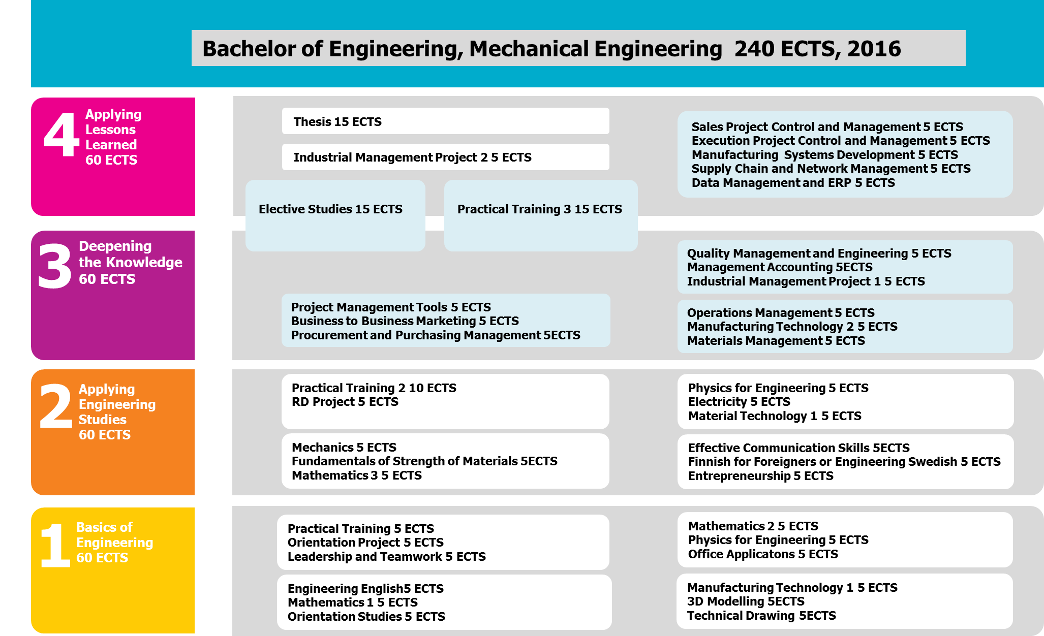

Basics of Engineering 60 ECTS
o Basics of production and product design
o Basics of project planning and working in projects
o Communication
o Mathematics and natural sciences
o Practical training

Applying Engineering Studies 60 ECTS
o Production and product design
o Mathematical skills development
o R & D project and its challenges
o Languages
o Entrepreneurship and Business
o Practical training
Creating the Knowledge 60 ECTS
o Project management and management tools
o International business, sales and marketing
o Quality Management
o Logistics and its sub-areas
o Industrial based project and its management
o Elective studies according to their own orientation
o Practical training

Applying Lessons Learned 60 ECTS
o Project management and control
o Sales and marketing in an international environment
o Supply chain management and networks
o Elective studies according to their own orientation
o Practical training
o Thesis

The thesis is 15 credits. The thesis project, including working and writing the thesis report, will usually take place in the fourth year of studies, in the spring term. It is usually done for and with a company. Students should find a topic from a company which they are interested in as a potential future employer. In many cases, the thesis leads to a job in this company or similar kind of work in another company after graduation. The thesis topic/ project could and should start being looked for after the third year of studies.

https://portal.savonia.fi/amk/fi/opiskelijalle/opetussuunnitelmat/testiops?yks=KT&krtid=983&tab=4
Development of Expertise
Basic studies provide students with a good knowledge of engineer's basic competences in mathematics, natural sciences, communication and information technology. These skills are essential in an engineer's work and for professional studies.
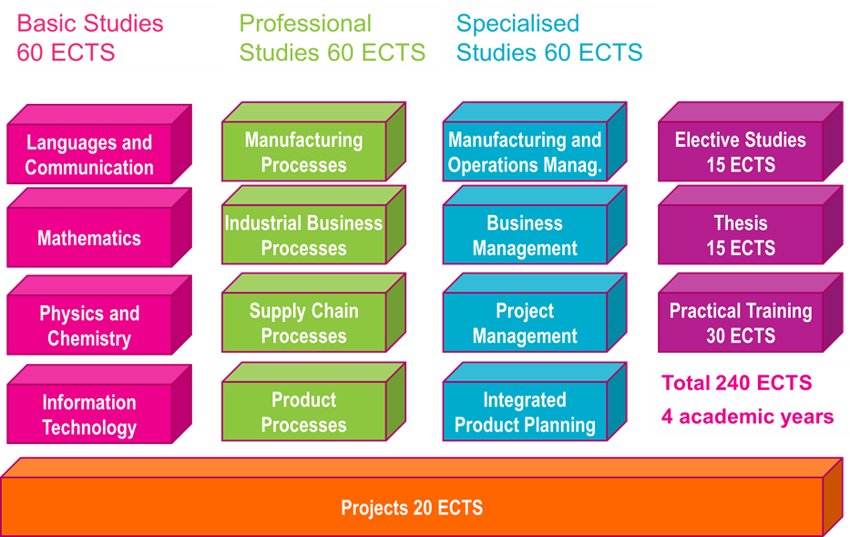
Professional studies provide students with a good knowledge of industrial processes and engineer's basic competences in mechanical engineering, production and logistics. These studies provide students also with a good knowledge and understanding of business processes and business life in society.
Specialised studies deepen students' theoretical understanding and practical skills in an engineer's work and make students learn to apply theories into practical cases.
Projects are an integral part of the implementation of the programme. Engineering skills, including working life skills are learned via projects. Good interpersonal and communication skills are required as many graduates will work on global projects involving people representing a wide range of nationalities. Different types of networks and management of these networks are an essential part of engineering skills.
Career possibilities:
Mechanical engineers have a wide range of career opportunities. The students' wide range of technology and business studies and practical training will help to find individual career paths and interests. A career and personal interests are rarely clear at the beginning of the studies.
The mechanical engineer may also find employment in public organizations, such as in city, state and local government positions. Third sector organizations can also provide work for mechanical engineers having knowledge of business and logistics.
Mechanical engineer positions vary from experts to managers. Various tasks related to the design and development of products and production are common. These design and development activities are most often organized as projects. That is why projects and their practices are learned in detail during the studies.
Jobs in Mechanical Engineering are usually business tasks that require engineering expertise. The workplace is often an international technology company in the field of export. For example, technical products and services are not usually sold by the business graduates, but by the engineers.
A mechanical engineer specialized in industrial management often works with and between a wide variety of organizations and entities. For example, a production planner is involved in sales, purchasing and production. Sales and marketing engineers are dealing with the customer, the production planner, product development and financial management, possibly even taking into account the cultural and communicational aspects.
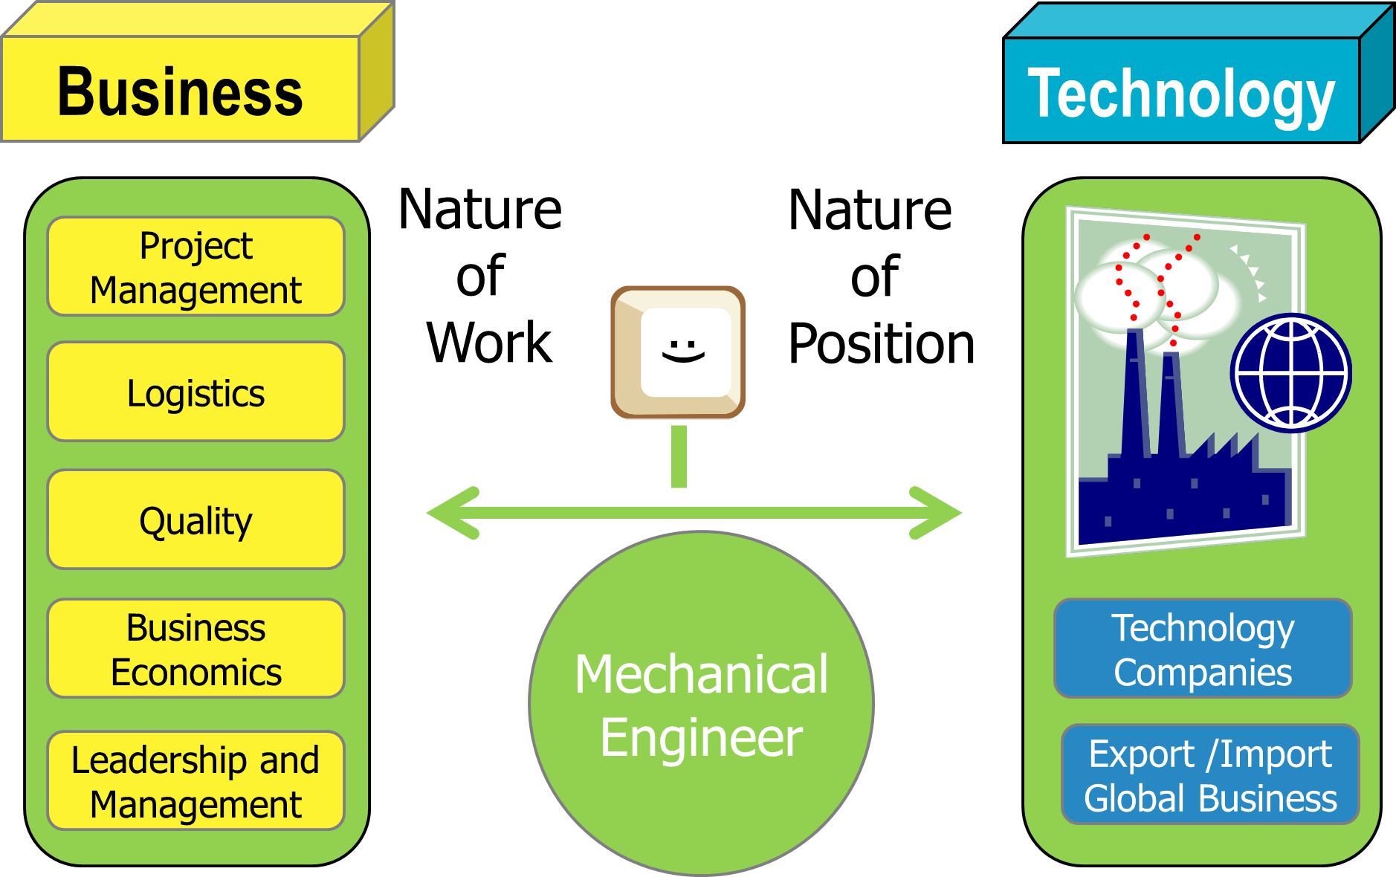

Titles
Graduates of Bachelor of Mechanical Engineer are often combined with the tasks and careers described by the words such as Project / Sales / Quality / Procurement / Purchasing / Production / Product / Machine / Development / Product Development / Maintenance followed by the titles such as Designer / Manager / Director / Coordinator / Specialist / Consultant. Different kinds of foreman duties are also common.
So, for example, titles for mechanical engineers can be:
o Project Engineer, Project Manager, Project Director
o Sales Engineer, Sales Manager, Marketing Manager
o Quality Engineer, Quality Coordinator, Quality Manager
o Purchasing Engineer, Purchasing Manager, Warehouse Manager
o Production Planner, Production Manager
o Installation Supervisor, Inspection Engineer
o Maintenance Engineer, Service Engineer, Foreman
o Development Engineer, Design Engineer, Patent Engineer
o Business Advisor, Consultant, CEO
o Trainer

Possibilities to continue studies after graduation:
Graduates can apply directly to study for a university master degree (Master of Science). EUR-ACE will provide validity in the European Union area.
The University of Applied Sciences graduate degree is Master of Engineering. These programmes are usually designed for students in full-time employment, and they take one to two years. The Master of Engineering degree gives the same qualification for public office as a Master of Sciences degree.

https://portal.savonia.fi/amk/fi/opiskelijalle/opetussuunnitelmat/testiops?yks=KT&krtid=983&tab=5
Methods and implementation
Savonia provides education which is guided by so called OIS thinking. The objective is to combine high-quality learning and teaching with the working life oriented research and development assignments. OIS comes from the words Open Innovation Space. The student is an active doer and he or she studies in various studying environments in different teams, communities and eLearning environments. The students of different study fields, the teachers, the partners working in research and development tasks and the representatives of the working life carry out diverse practice-based assignments in close cooperation. In this way the theory and the practical assignments are combined with the studies.
Cooperation
The technology industry is the most important business in the North Savo region with its 1.7 billion euros revenue and about 800 million euros of exports each year. In the region, there are 9 000 directly employed employees and 13 500 employees who are employed indirectly in the technology industry. Many of the region’s businesses operate in international markets at the leading edge of their field of operation. Their core know-how is concentrated around commercial vehicles, such as state-of-the-art forestry equipment, mining and pile-driving machines, and in furnace and boiler technology in the field of energy technology.
The Department of Mechanical Engineering co-operates with the region’s industrial enterprises while undertaking their research, development and innovation work. The businesses can participate in Savonia’s projects by partially funding the activities or they can directly purchase the different RDI services provided by the DPME’s experts.
The significant volume of functions demonstrates the fact that the RDI Unit of the Department of Mechanical Engineering has succeeded in identifying the current and future needs for development of the local businesses. With many of the businesses, the current co-operation can be described as a true partnership; i.e. there are mutual benefits, continuity and varied actions. The internships, thesis and other project works conducted as part of the education represent the foundation for co-operation with these companies, but also the RDI projects are based on collaboration with the businesses.
EUR-ACE authorities praised active cooperation with companies. Students often make course practice work and development plans as part of the course for companies. The study plan includes a number of projects,
Research
The Savonia University of Applied Sciences research and development work is shown to students in everyday life via the project and thesis work. Savonia has selected four areas of focus for education and research, development and innovation (RDI). One of them that is very important to Mechanical Engineering is integrated product development. Research is undertaken in collaboration with enterprises and other organizations.
On the industrial management side, the focus is on ECP (Engineering-Procurement-Construction) projects, or large delivery projects, as well as processes and supply chains.
Internationality
Finns and Finnish immigrants and a number of different nationalities are studying in this programme. The student in this programme is recommended to have an exchange period or training also somewhere outside Finland. Students have the opportunity to complete a double degree in Windesheim University of Applied Sciences in the Netherlands.


The programme and Savonia University of Applied Sciences have a variety of seminars and international summer courses, collaborative projects, and linguistic and cultural diversity training. Savonia University of Applied Sciences has foreign university partners in more than 30 countries.

