SS24 verkkoped- ops/Sosionomin tutkinto-ohjelma, viimeisin versio opsiin 23.4.2023/pt, ei enää muuteta

Degree Programme in Social Services

This curriculum is a translation of the curriculum of the Finnish degree program.

Curriculum responsibility: Anne Huovinen

Basis of Education

The Bachelor’s Degree Programme in Social Services is a 3.5-year, 210 ECTS programme which leads to a Bachelor of Social Services (UAS) degree. The skills and expertise gained through this programme are in compliance with the requirements of the EU in view of the level of higher education enabling free movement of labour and experts.
The Bachelor of Social Services (UAS) degree responds to changing needs in society. The education provides the student with professional skills and competences to meet the needs of working life. A Bachelor of Social Services (UAS) can be employed by municipalities, wellbeing services counties, private companies or third sector organisations and work as a specialist in social guidance and/or early childhood education / correctional services or work as a self-employed person in those fields. After graduation, a Bachelor of Social Services can work in various tasks in, for example, municipal education and culture, disability services, immigration work, child welfare, labour administration, the Social Insurance Institution of Finland (KELA) and criminal sanctions.
The graduate of Bachelor of Social Services (UAS) is an expert in the social sector, whose work emphasizes interaction and group work skills, guidance skills, competence in work methods in the social field as well as network skills. After graduation, the student will have abilities to renew welfare services and develop cooperative and inclusive work and support methods for clients in different life situations. A Bachelor of Social Services knows the legislation concerning the social field, the social welfare and social security systems, the operating environments of social and health care sector, as well as various ways to produce social and health care services. A Bachelor of Social Services is able to anticipate social changes and is willing to be involved in providing and developing client-oriented social services. Service integration and digitalization are changing service systems. With the degree, you can use different digital platforms and develop client-oriented electronic services. You recognize the possibilities of wellness technology, robotics, artificial intelligence, etc. in the field. Future experts in the social field are expected to have abilities to reform social and welfare services within the limits of existing resources, use information and communication technology at work and develop cooperative and inclusive forms of support for clients in various life situations.
The aim of the UAS education is to provide higher education based on research and science that prepares the student for specialist jobs and supports professional growth. Another aim is to carry out applied research, development and innovation activities to serve the UAS education and the needs of working life and to promote regional development. The aim of Savonia UAS is to serve the Northern Savo region and the eastern Finland area where the regional vitality is influenced by the constantly changing and internationalising operational environment.
According to the Act on Qualification Requirements for Social Welfare Professionals (272/2005 § 6), the job title corresponding to the title of Bachelor of Social Services (UAS) is social instructor.
The Act on Early Childhood Education and Care 13.7.2018/540 27 determines the qualification of a Bachelor of Social Services in Early Childhood Education as follows: The qualification requirement for the tasks of a Bachelor of Social Services in Early Childhood Education is at least a university of applied sciences degree in social and health care, which includes studies of at least 60 credits focused on early childhood education and social pedagogy, which can be regulated in more detail by a government decree, or a Bachelor of Social Services degree, which has been supplemented by the mentioned studies.
The professional skills of a Bachelor of Social Services can be described by both generic and specific competences of a Bachelor of Social Services (competence areas). The generic competences are common to all UAS degree programmes, but their special features and importance may vary in different professions and jobs. The generic competences provide a good basis for working life skills, collaboration and developing professional skills. The student can develop desired skills and competences by content and pedagogical choices during the studies.
Licensing Social Welfare Professionals:
The National Supervisory Authority for Welfare and Health (Valvira) grants licensing, upon application and upon the announcement of the UAS, the right to act as a licensed social welfare professional. Completed social services studies, 210 ECTS, and their content according to the curriculum are the prerequisites for licensing. The UAS must verify that the graduating social welfare professional possesses the required skills and competences.

Competence Standards
The qualification of a Bachelor of Social Services is at the European (EQF) and Finnish level 6 (national qualifications framework).
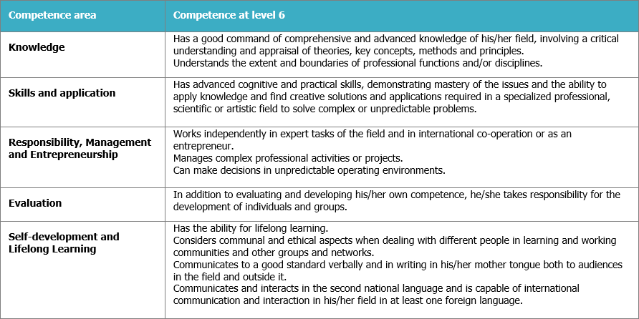
Common competences of UAS degrees:
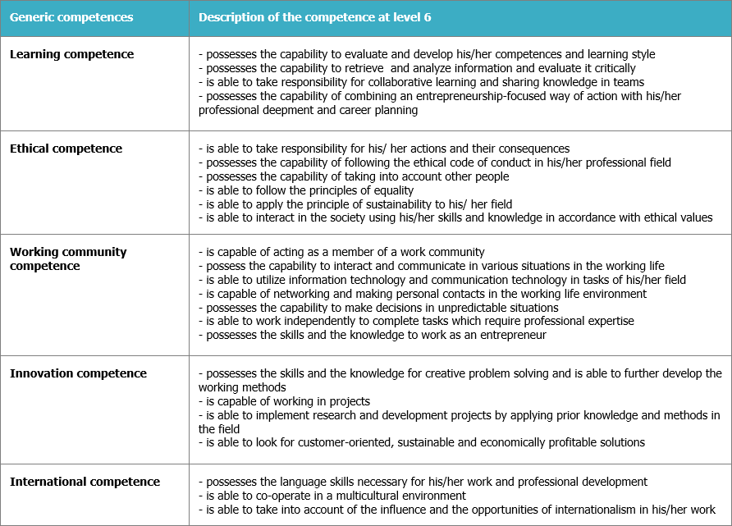
Specified competences of a Bachelor of Social Services (UAS):

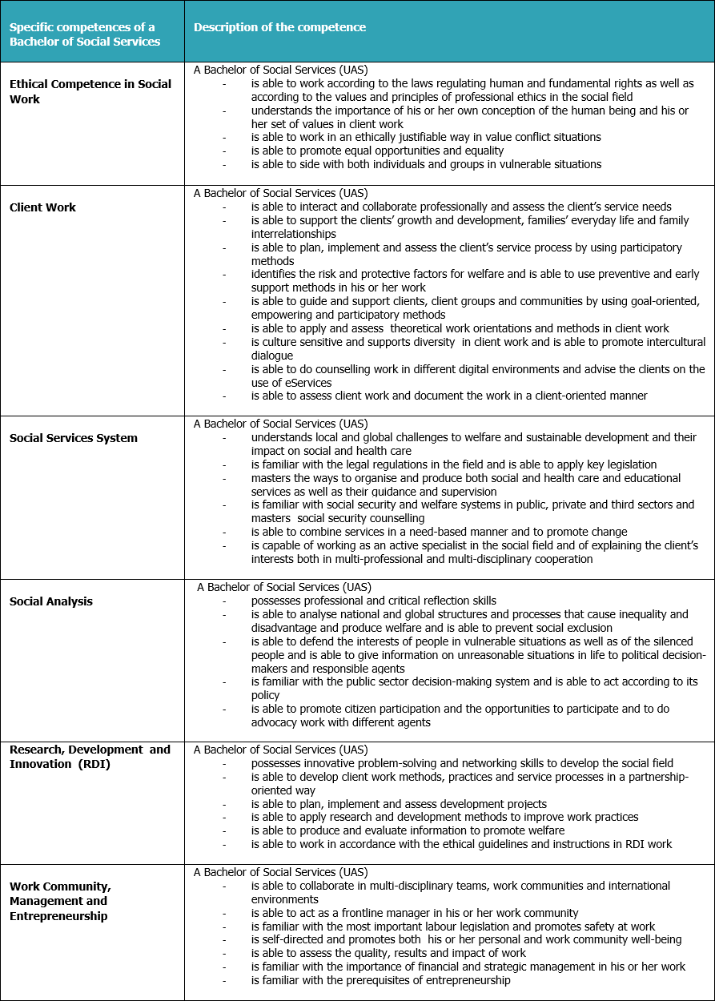

Structure of Studies
The extent of the Degree Programme in Social Services (UAS) is 210 ECTS. According to the curriculum, the student is expected to complete 60 ECTS during each study year. This means 1600 hours of student work. In an online degree programme, the student studies mainly the entire degree online. The student's work consists of, for example, time-bound participatory teaching online, distance and independent study and internships. The studies include research and development activities in close connection with working life.
During the first academic year the student gains basic knowledge of the operating environments in social work, early childhood education and health care and client work. The student adopts a reflective, exploratory and developing approach to work and learns the guidelines of professional ethics. During the second year the student becomes familiar with social guidance and early childhood education as well as diverse client work methods and services in the social field. During the third and fourth years of studies the student deepens his or her professional skills and competence in early childhood education and social guidance. The student learns, applies and deepens his or her research-based development skills, inclusive social competence and management skills.
Types of  Studies | Credits | Description of Studies
Basic Studies | 30 ECTS | Basic studies consist of introduction to UAS studies, learning objectives and content of education. Basic studies form a solid foundation for professional growth, responsible working, continuous learning and the development of language and communication skills.
Professional  Studies | 110 ECTS | Professional studies provide the student with knowledge, skills and attitudes needed in the work of a Bachelor of Social Services (UAS). These studies consist of compulsory and alternative professional studies.  The compulsory professional studies (95 ECTS) offer a comprehensive knowledge base in the social field.  The student also chooses advanced professional studies, 3x5 ECTS totalling 15 ECTS  - early childhood education expert’s study path  - social guidance expert’s study path  - correctional services expert’s study path  1)The early childhood education expert chooses the courses Early Childhood Education Pedagogy, Special Support for the Child and Empowering Participation of the Child as well as the course Early Learning and Guidance. The student learns skills that are needed when working with families in early childhood education and care, special education and family work. The student learns skills to support growth and guide clients. He or she learns to work in teams as a social work specialist and develop his or her professional skills taking the needs of individuals and families into account. The student is required to complete at least 60 ECTS credits of early childhood education studies to be qualified to work within early childhood education and care.  2)The social guidance expert chooses the following courses: Social Guidance for Adults, Guidance Work for Children and Families, and Structural Social Work, Communication and Advocacy. Skills and abilities gained through the courses are needed when working in e.g. day centres, family centres, supported housing, service housing, child welfare work units, rehabilitation homes, home care, social and health care centres, employment services centres as well as when working for the Social Insurance Institution in Finland and for other insurance institutions. The student learns professional skills to guide, counsel and support individuals, families and communities in using public services as well as to coordinate various support forms. The aim is to promote the wellbeing and participation of individuals and families by enhancing life-management skills and functional abilities.  3) The correctional services expert chooses the following courses: Legality and Good Governance in Corrections, Penal Systems and Criminal Behavior, and Safety and Security in Corrections. Skills and abilities gained through the courses are needed to encounter and treat clients equally, increase clients’ awareness of fundamental human rights and freedoms, apply the work methods of rehabilitative work, prevent social exclusion, disengage clients from criminal behavior and support their inclusion in society. Collaboration with the third sector players and various communities is highlighted in gained competence.
Internship | 45 ECTS | During the internship the student becomes familiar with practical work and learns to choose, use and apply various practices and work methods. The internship prepares the student to develop new solutions and the quality of practices by applying client-oriented and working-life-based methods. The internship also prepares for working life by deepening student’s professional skills and competence. It also makes it easier for the student to find employment in the field. The student learns to think critically and combine theory with practice in real-life situations. The internship can also be completed abroad.  Basic and professional studies include guided and supervised internship periods (3x15 ECTS) to be completed in close cooperation with working life in different service, rehabilitation and work units, as well as in early childhood education and development projects.  The student is required to complete a certain number of credits before the start of his or her internship period:  - Professional Training (Orientation) SSOHAR 15 ECTS. Requires 30 credits of studies in the degree programme of Social Services to have been completed before the start of the internship  - Professional Training (Practical Methods) SSMHAR 15 ECTS credits. Requires 90 credits of studies in the degree programme of Social Services to have been completed before the start of the internship  - Advanced Practical Training SSKSOHAR 15 ECTS credits. Requires 140 credits of studies in the degree programme of Social Services as well as Professional Training (Practical Methods) SSMHAR to have been completed before the start of the internship  The student is responsible for:  - finding the internship placement and setting the objectives  - reporting on the internship in accordance with the internship plan
Thesis | 15 ECTS | Thesis is a working-life-oriented learning process for the student as it is supervised, guided and evaluated by professionals. The aim of the thesis is to improve the viability of working life and at the same time deepen the professional skills and knowledge of the student in the chosen topic. A thesis can be research-based or/and practice-based.  In the thesis process the student is responsible for  - finding a thesis topic integrated with working life  - increasing his or her knowledge in the subject field and creating the framework for the assignment  - completing the assignment and reporting on the process and outcomes  - finalising the thesis and drafting information material  The thesis offers a flexible way of entering the working life and a good opportunity for networking in the field.
Alternative  Studies | 10 ECTS | Alternative studies direct and support the development of the student’s expertise according to his or her interests. The student can choose from joint study modules at Savonia UAS or courses that are arranged by other faculties at Savonia UAS or by other schools or universities. The studies arranged elsewhere have to correspond to the level of studies in higher education.
Total | 210 ECTS

Development of Expertise
In the curricula at Savonia UAS the study modules form extensive study entities. Thus they support the development of the student’s professional expertise and the student’s development as a whole. This also enables the combination of teaching with the working-life-oriented research and development activities.
Social constructivist learning theory and integrative pedagogy form the basis of teaching. According to the social constructivist learning theory, the student searches information actively and independently, evaluates it critically and is a knowledge constructor in interaction with others. The student builds knowledge based on his or her experiences and links that to his or her prior knowledge and views by using reflection. This way the student develops awareness of his or her own learning. According to integrative pedagogy, the student combines sociocultural, practical and theoretical knowledge. The student reflects on his or her own activities and learning in the light of integrated knowledge and based on phenomena.
The Bachelor of Social Services curriculum has been planned so that the
- the degree programme provides the student with the knowledge, skills and competence required in the working life
- the studies ensure the development of the student’s professional expertise
The student
- drafts a personal study and career plan (PSP) including the recognition of prior learning (RPL)
- is responsible for the progress of his or her studies
The teachers and other personnel at Savonia UAS guide and support the students in defining and achieving the personal learning goals. Each student has his or her personal teacher tutor to support professional growth throughout the studies. Students conduct self-evaluation of their professional growth annually.
The student’s professional growth is described in the annual objectives and semester themes. The annual objectives help students, teachers and working-life representatives understand the stages through which professional growth develops.
After completing the degree, a Bachelor of Social Services (UAS) is familiar with the service systems providing and strengthening participation, safety and welfare and with the forms of producing them in social and health care services and education. A Bachelor of Social Services is able to anticipate future changes as well as provide and develop social services and guidance. He or she is able to guide and support different people and clients at various stages of growth, development and learning. He or she is also able to support and engage children, young people, families and different groups of people in changing life situations and with challenges in everyday life. A Bachelor of Social Services is able to work as a specialist in multi-professional social and health care environments as well as in development and managerial jobs. In his or her work a Bachelor of Social Services follows the ethical guidelines in the social field.
Annual themes:
Annual themes | Autumn and spring term themes | Competence targets
1st year  Basics of Social Services (60 ECTS) | Skills, competences and knowledge base in the  social field (30 ECTS)  Basics of client work and ethics at work (30 ECTS) | The student is able to observe a human being holistically and understands his or her place in the chain of generations. The student understands the impact of changes in society on human growth and living conditions. The student views social work and promotion of welfare as part of social and health care services. The student is able to use his or her knowledge of values, pedagogy, data management and data protection as well as of client encounter during the first client work internship period.
2nd year  Client-oriented work in the social field (60 ECTS) | Client-oriented social  services (30 ECTS)  Client-oriented working methods (30 ECTS) | The student is able to work in interaction with the client in various contexts in social services and early childhood education. He or she is familiar with the client work process, is able to set goals for it and support clients in their everyday lives. The student is also able to apply the knowledge of case management, social security, social rehabilitation, family work and child protection as well as of inclusive,  practice-based client work methods to his or her work during the internship.
3rd year  Development of social work and early childhood education (60 ECTS) | Exploratory development of work (30 ECTS)  Management and expertise in the social field (30 ECTS) | The student starts to deepen his or her professional skills and competence according to the chosen study path. The student is able to work as an active work community member and as a proactive manager. He or she is familiar with the elements of project work and is able to develop services in multi-professional collaboration. The student is able to apply R&D knowledge to his or her own thesis planning and implementation. He or she is also able to work as a budding professional in the social field and early childhood education during the advanced internship period.
4th year  Influencing in the social field and early childhood education (30 ECTS) | Critical social competence and influencing (30 ECTS) | The student possesses working life skills and basic entrepreneurial skills and knows the factors that have an impact on well-being at work. He or she is able to apply theoretical knowledge to observing and developing  practical phenomena. The student is able to work as a specialist in his or her own field and masters the methods of social influence. The student is able to assess his or her own professional competence and work as an independent specialist in the social field.

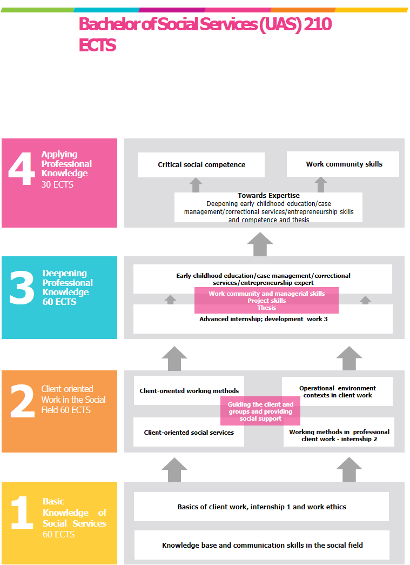

Methods and implementation

During studies, theory and practice are extensively and interestingly integrated into student learning and development of organisations. Education is typically multiform and multidisciplinary with no ties to time and place.
In an online degree programme, you mainly study online based on the social constructivist concept of learning and integrative pedagogy. The studies include real-time online meetings, time-bound participatory teaching online, and independent or interactive group work online. During the studies, the students often work in small groups and interact with other students and teachers. This requires a strong sense of self-direction, planning and commitment to active and independent studying. The studies include three internships (3 x 10 weeks), which require full-time attendance at the place of the internship. 1 ECTS means about 27 hours of work, which is good to remember when planning your studies, work and other life.
Various online learning environments are used in online studies. Savonia uses Moodle online learning environment, Microsoft 365 tools, and Zoom as an online conferencing tool. Most teaching and guidance sessions are organized on Zoom. Online studying requires a working Internet connection, adequate hardware, basic IT skills as well as motivation to start using a variety of online platforms.
At the beginning of the studies, there are two orientation days online where participation is compulsory for all students. There are time-bound participatory teaching and meetings online every other week on Mondays and Tuesdays for about 6 hours between 8 am and 4 pm.
The student’s professional growth is supported by professional guidance throughout the studies. Personalised education enables alternative study methods and individual study paths in accordance with the student’s own goals. Speeding up of studies is possible, but it may require participation in the teaching of different groups, in which case the teaching days can be held at different Savonia campuses or online.
Savonia makes extensive use of the recognition of prior learning and learning in the workplace as part of the student's personal study plan. The student can deepen or expand his or her knowledge and skills by selecting courses from the offerings of Savonia's national and international higher education partners.
The multiform networking of the teaching staff enables the working- life -oriented education at Savonia UAS. These networks also guarantee the continuous development of substance expertise. The personnel provide learning opportunities and supports the student’s learning. The Student Services Office, the Library and Information Services, the International Services and other supportive services help the students in their studies. The studies take into account social responsibility, accessibility, sustainable development and global challenges.
Internationalisation is part of studies. The student has an opportunity to learn about internationality at different stages of the studies and improve his or her cultural competence by studying abroad through various exchange programmes. The student is required to complete at least 5 ECTS credits of studies in a foreign language (excluding language studies). The student can improve intercultural skills also by acting as a peer tutor student and help exchange students and by working for example with immigrants.
The student has an opportunity to complete at least 60 ECTS of studies in English. The studies could include, for example, the following: the course Multicultural Work SSMOCUW 5 ECTS and optional 5-10 ECTS course in English, professional training 30 ECTS abroad, and 20 ECTS from the joint studies for social services and health care in the international Bachelor’s Degree Programme in Nursing. Any course can be taught in English if other than Finnish speaking students participate in the course or for some other strong reason. Every student completes at least 5 ECTS Swedish language studies. The student can also include alternative language studies into his or her personal study and career plan.
Finnish language and communication studies are integrated into the social services courses so that the student achieves the communication and interaction skills necessary for studying, practicing the profession, professional development, as well as for postgraduate studies.
The student can choose child- and family-oriented or guidance-focused courses in the optional professional study paths of an early childhood education expert and a social guidance expert. He or she gains skills in supporting and guiding a person’s growth in client work, learns to work in multi-professional teams as a social work and education specialist and develop his or her professional practices considering the needs of individuals and families. Early childhood education and social guidance skills are needed when working with families in early childhood education and care, special education, youth work, family work, child protection or in rehabilitation and care for the disabled. The student can choose at least 60 ECTS credits of early childhood education and social pedagogy studies in order to be qualified for early childhood education work (Bachelor of Social Services in Early Childhood Education).
A student who wishes to become an entrepreneur may choose courses concerning the development of a business idea, business model and customer testing from joint study modules at Savonia UAS. The student then chooses to do his or her internship in different companies where he or she can become familiar with entrepreneurship in social and health care. In addition to being an entrepreneur, the entrepreneurial studies aim at increasing awareness of entrepreneurial activities and at improving knowledge of entrepreneurship and business life.

