SS21KM Degree Programme in Social Services

Basis of Education

The Bachelor’s Degree Programme in Social Services is a 3.5-year, 210 ECTS programme which leads to a Bachelor of Social Services (UAS) degree. It is possible to complete the studies in 2,5-3,5 years. The skills and expertise gained through this programme meet the requirements of level 6 in the European Qualifications Framework (EQF).

Social services is a constantly changing service sector. The education provides the student with professional skills and competences to meet the needs of working life. In the future the lines between different service sectors will be blurred and the Service production will be more client-oriented and based on contracts and cooperation between different service providers. Seamless service chains and networking service production assumes new skills and competence, coordination of activities, division of work and efficiency. Future experts in the social field are expected to have abilities to reform welfare services within the limits of existing resources, to adopt information and communication technology and to develop cooperative and inclusive forms of support for clients in various life situations. Education provides the student expertise that meets the needs of working life.

A Bachelor of Social Services (UAS) can be employed by municipalities, private companies or third sector organisations and work as a specialist in early childhood education and social pedagogy. social counselling and education. There will be new jobs available for experts in social services in local education and culture, in employment and economic services, in correctional services and in the Social Insurance Institution of Finland (KELA). In addition, some task areas in social work will be redefined and this is expected to increase the graduates’ possibilities to make use of their new kind of skills and expertise in practical work. After graduation the student will have abilities to work as a Bachelor of Social Services in early childhood education, renew welfare services and develop pedagogical, cooperative and inclusive work and support methods for children and families. clients in different life situations. A Bachelor of Social Services knows the social welfare and social security systems, early childhood education environments as well as is able to forecast future changes in society and willing to participate in service production and development. She or he also knows how to work in digital environments. the ways to produce social and health care services. A Bachelor of Social Services is able to forecast future changes and is prepared to participate in service production and development and work in digital environments. In the future the lines between different service sectors will be blurred and the service production will be more client-oriented and based on contracts and cooperation between different service providers. Seamless service chains and networking service production assumes new skills and competence, coordination of activities, division of work and efficiency. Future experts in the social field are expected to have abilities to reform welfare services within the limits of existing resources, to adopt information and communication technology and to develop cooperative and inclusive forms of support for clients in various life situations.
The general aim of the UAS education is to provide higher education based on research and science that prepares the student for specialist jobs and supports professional growth. Another aim is to carry out applied research, development and innovation activities to serve the UAS education and the needs of working life and to promote regional development. The aim of Savonia UAS is to serve the Northern Savo Region and the eastern Finland area where the regional vitality is influenced by the constantly changing and internationalising operational environment.

The Act on Social Welfare Professionals (817/2015) came into effect on 1 March 2016. The degree title earned at UAS is Bachelor of Social Services (UAS) and, according to the Act on Qualification Requirements for Social Welfare Professionals (272/2005 § 6), the corresponding job title is social instructor. A student can also gain eligibility for a profession of a kindergarten teacher during the studies if he or she wishes to do so. The professional skills of a Bachelor of Social Services can be described in both generic and specific competences of a Bachelor of Social Services (competence areas). The generic competences are common to all UAS degree programmes, but their special features and importance may vary in different professions and jobs. The generic competences provide a good basis for working life skills, collaboration and developing expertise. The student can develop desired skills and competences by content and pedagogical choices during the studies.
Licensing Social Welfare Professionals:
Bachelors of Social Services working in early childhood education do not have an obligation to register nationally. Yet registration is recommended if one wishes later to work in the field of social welfare. The National Supervisory Authority for Welfare and Health (Valvira) grants licensing, upon application and upon the announcement of the UAS, the right to act as a licensed social welfare professional. Completed social services studies, 210 ECTS, and their content according to the curriculum are the prerequisites for licensing. The UAS must verify that the graduating social welfare professional possesses the required skills and competences.

Competence Standards
The qualification of a Bachelor of Social Services is at the European (EQF) and Finnish level 6 (national qualifications framework).

Alla olevaan taulukkoon on valmis käännös Savoniassa. Tähän ei tule nyt muutoksia.
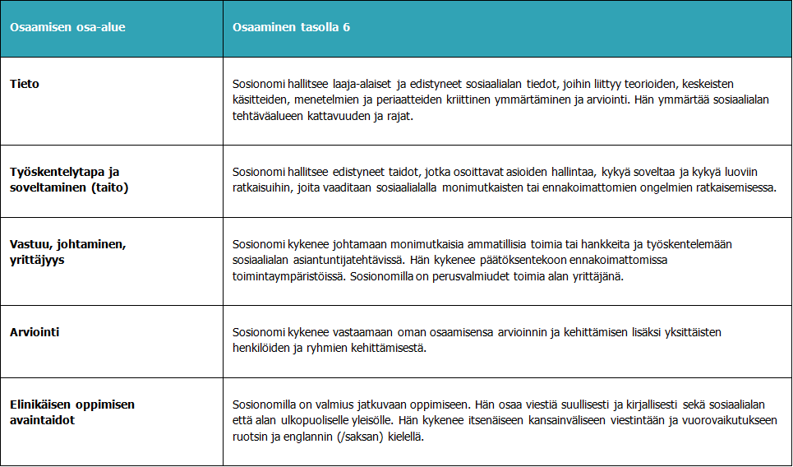
Common competences of UAS degrees:
Alla olevaan taulukkoon on valmis käännös Savoniassa. Tähän ei tule nyt muutoksia.

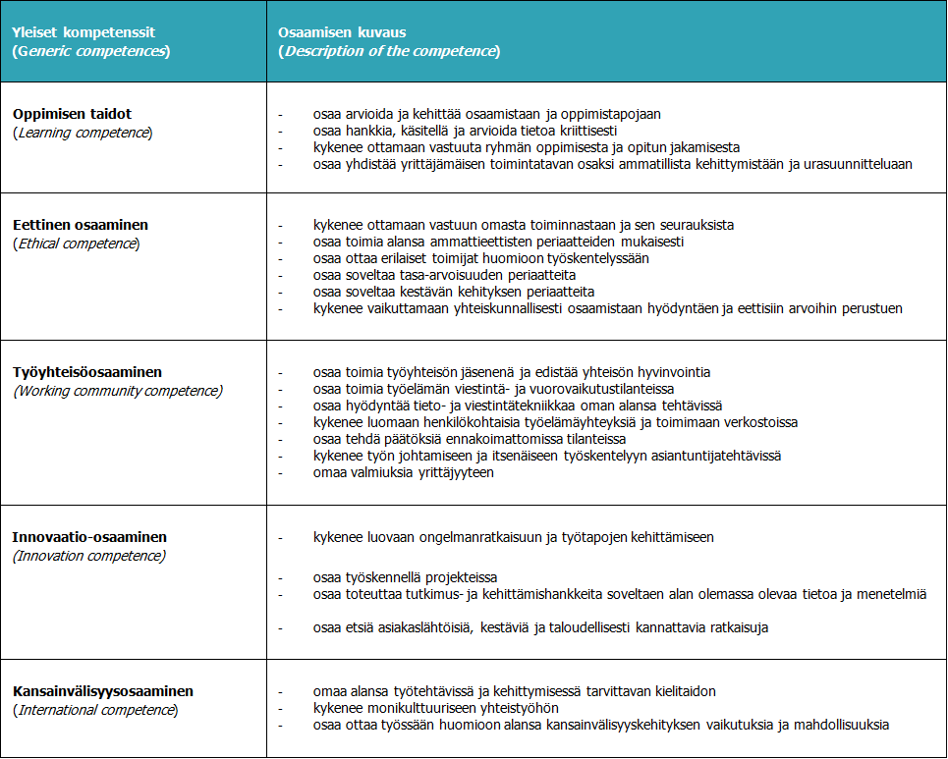

Specified competences of a Bachelor of Social Services (UAS):

Specific competences of a Bachelor of Social Services | Description of the competence
Ethical Competence in Social Work | A Bachelor of Social Services (UAS)  - is able to work according to the laws regulating human and fundamental rights as well as according to the values and principles of professional ethics in the social field  - understands the importance of his or her own conception of the human being and his or her set of values in client work  - is able to work in an ethically justifiable way in value conflict situations  - is able to promote equal opportunities and equality  - is able to side with both individuals and groups in vulnerable situations
Client Work | A Bachelor of Social Services (UAS)  - is able to interact and collaborate professionally and assess the client’s service needs  - is able to support the clients’ growth and development, families’ everyday life and family interrelationships  - is able to plan, implement and assess the client’s service process by using participatory methods  - identifies the risk and protective factors for welfare and is able to use preventive and early support methods in his or her work  - is able to guide and support clients, client groups and communities by using goal-oriented, empowering and participatory methods  - is able to apply and assess theoretical work orientations and methods in client work  - is culture sensitive and supports diversity in client work and is able to promote intercultural dialogue  - is able to do counselling work in different digital environments and advise the clients on the use of eServices  - is able to assess client work and document the work in a client-oriented manner
Social Services System | A Bachelor of Social Services (UAS)  - understands local and global challenges to welfare and sustainable development and their impact on social and health care  - is familiar with the legal regulations in the field and is able to apply key legislation  - masters the ways to organise and produce both social and health care and educational services as well as their guidance and supervision  - is familiar with social security and welfare systems in public, private and third sectors and masters social security counselling  - is able to combine services in a need-based manner and to promote change  - is capable of working as an active specialist in the social field and of explaining the client’s interests both in multi-professional and multi-disciplinary cooperation
Social Analysis | A Bachelor of Social Services (UAS)  - possesses professional and critical reflection skills  - is able to analyse national and global structures and processes that cause inequality and disadvantage and produce welfare and is able to prevent social exclusion  - is able to defend the interests of people in vulnerable situations as well as of the silenced people and is able to give information on unreasonable situations in life to political decision-makers and responsible agents  - is familiar with the public sector decision-making system and is able to act according to its policy  - is able to promote citizen participation and the opportunities to participate and to do advocacy work with different agents
Research, Development and Innovation (RDI) | A Bachelor of Social Services (UAS)  - possesses innovative problem-solving and networking skills to develop the social field  - is able to develop client work methods, practices and service processes in a partnership-oriented way  - is able to plan, implement and assess development projects  - is able to apply research and development methods to improve work practices  - is able to produce and evaluate information to promote welfare  - is able to work in accordance with the ethical guidelines and instructions in RDI work
Work Community, Management and Entrepreneurship | A Bachelor of Social Services (UAS)  - is able to collaborate in multi-disciplinary teams, work communities and international environments  - is able to act as a frontline manager in his or her work community  - is familiar with the most important labour legislation and promotes safety at work  - is self-directed and promotes both his or her personal and work community well-being  - is able to assess the quality, results and impact of work  - is familiar with the importance of financial and strategic management in his or her work  - is familiar with the prerequisites of entrepreneurship

Structure of Studies
The extent of the Degree Programme in Social Services (UAS) is 210 ECTS. According to the curriculum, the student is expected to complete 60 ECTS during each study year; this means 1600 hours of student work. The student’s work comprises e.g. activating contact lessons, independent and online studies and internship. The internship is done in close cooperation with different working-life organisations providing early childhood education and social services. The internship can also be completed abroad. The studies include practice-based RDI activities.
During the first academic year the student gains basic skills in social work, early childhood education, health care and client work and becomes aware of himself or herself as a learner. The student adopts a reflective, exploratory and developing approach to work and learns the guidelines of professional ethics. During the second year the student becomes familiar with social counselling and early childhood education, diverse client work in the social field and social services. During the third and fourth years of studies the student deepens his or her professional skills and competence in early childhood education and case management. The student learns, applies and deepens his or her research-based development skills, inclusive social competence and management skills.

Types of  Studies | Credits | Description of Studies
Basic Studies | 30 ECTS | Basic studies consist of introduction to UAS studies, learning objectives and content of education. Basic studies form a solid foundation for professional growth, responsible working, lifelong learning and the development of language and communication skills.
Professional  Studies | 110 ECTS | Professional studies provide the student with knowledge, skills and attitudes needed in the work of a Bachelor of Social Services (UAS). These studies consist of compulsory and alternative professional studies.  The compulsory professional studies (95 ECTS) offer a comprehensive knowledge base in the social field.  The student also chooses advanced professional studies, 3x5 ECTS totalling 15 ECTS  - early childhood education expert’s study path  - case management expert’s study path  - correctional services expert’s study path a combination of the above mentioned study paths or  - an individual a study path focusing on e.g. entrepreneurship  1)The early childhood education expert chooses the courses Early Childhood Education Pedagogy, Special Support for the Child and Empowering Participation of the Child as well as the course Early Learning and Guidance.  These abilities are needed when working work with families in day care, special education and family work. The student learns skills to support growth and guide clients. He or she learns to work in teams as a social work specialist and develop his or her professional skills taking the needs of individuals and families into account. The student is required to complete at least 60 ECTS credits of early childhood education studies to be qualified to work within early childhood education. for working as a kindergarten teacher.  2)The case management expert chooses the following courses: Empowering Participation and Empowering Case Management, Rehabilitation and Supporting the Client and Services for Working-age People and Employment. These Skills and abilities gained through the courses are needed when working in e.g. day centres, supported housing, assisted living facilities, care homes, rehabilitation homes, home care and care institutions, social services centres, employment services centres as well as when working for the Social Insurance Institution in Finland and for other insurance institutions. The student learns professional skills to guide, counsel and support individuals, families and communities in using public services as well as to coordinate various support forms. The aim is to promote the wellbeing and participation of individuals and families by enhancing life-management skills and functional abilities.  3) The correctional services expert chooses the following courses: Legality and Good Governance in Corrections, Penal Systems and Criminal Behavior and Safety and Security in Corrections. Skills and abilities gained through the courses are needed to encounter and treat clients equally, increase clients’ awareness of fundamental human rights and freedoms, apply the work methods of rehabilitative work, prevent social exclusion, disengage clients from criminal behavior and support their inclusion in society. Collaboration with the third sector players and various communities is highlighted in gained competence.  - The student can choose both early childhood education  expert’s study path courses and case management expert’s study path courses to be included in his or her advanced professional studies. This enables the student to gain skills and competence in work practices at the individual, family and community level.  These skills are needed when providing early support, in problem  prevention and rehabilitation work in various operational environments, e.g. in child and youth work, child protection and different early support tasks.  - The student can combine different alternatives at Savonia UAS to be included in the advanced professional studies.  4) A student wishing to become an entrepreneur can choose innovation and entrepreneurship study path courses, the so called yPolku studies offered for all Savonia UAS students. In this case the student chooses to do his or her internship in care and other companies where he or she can learn about entrepreneurship in social and health care. Students can also choose courses to be included in the advanced professional studies from other universities of applied sciences. , e.g. correctional services studies.
Internship | 45 ECTS | Basic and professional studies include guided and supervised internship periods (3x15 ECTS) to be completed in close cooperation with working life in different service, rehabilitation and operational units and in development projects. During the internship the student becomes familiar with practical work and learns to apply knowledge and skills in working life. The supervised internship prepares the student for working life by deepening his or her professional skills and competence. It also makes it easier for the student to find employment in the field. The student learns to think critically and combine theory with practice in real-life situations. The student is required to complete a certain number of credits before the start of his or her internship period:  - Professional internship 1 SSOHAR1A/10 ECTS and SSOHAR1B/5 ECTS (30 ECTS)  - Professional internship 2 SSMHAR2A/10 ECTS and SSMHAR2B/5 ECTS (90 ECTS)  - Advanced internship SSKHARA /10 ECTS and SSKHARB/5 ECTS (150 ECTS).  The student is responsible for:  - finding the internship placement and setting the objectives  - reporting on the internship in accordance with the internship plan
Thesis | 15 ECTS | The thesis can be research or practice-based. It can also be a development work which is closely linked with current development needs in working life. The internship, project, research and data  acquisition studies and thesis work develop skills and competence needed in self-improvement and development of professional work. The thesis is a work and learning process supervised, guided and evaluated by professionals.  In the thesis process the student is responsible for  - finding a thesis topic integrated with working life  - increasing his or her knowledge in the subject field and creating the framework for the assignment  - completing the assignment and reporting on the process and outcomes  - finalising the thesis and drafting information material  The thesis offers a flexible way of entering the working life and a good opportunity for networking in the field.
Alternative  Studies | 10 ECTS | Alternative studies direct and support the development of the student’s expertise according to his or her interests. The student can choose from joint study modules at Savonia UAS or courses that are arranged by other faculties at Savonia UAS or by other schools or universities. The studies arranged elsewhere have to meet the requirements of level 6 in the European Qualifications Framework (EQF). correspond to the level of studies in higher education.
Total | 210 ECTS

Development of Expertise
Studies progress as presented in the course table and provide the qualification to work as a Bachelor of Social Services in early childhood education. The prior Vocational Qualification in Education and Guidance provides the basis for UAS competencies, which will be further deepened in the fields of early childhood education and social pedagogy.
The teachers and other personnel at Savonia UAS guide and support the students in defining and achieving the personal learning goals. Both teachers and peer groups support in planning the student’s personal study path and career development. Each student has his or her personal teacher tutor to support professional growth throughout the studies. Students conduct self-evaluation of their professional growth annually. A peer group supporting professional growth led by the teacher tutor meets every semester. At the final stage of studies the student creates a blog into personal learning environment (PLE) and prepares a virtual CV for entering working life.
The student’s professional growth is described in the annual objectives and semester themes. The annual objectives help students, teachers and working-life representatives understand the stages through which the professional growth develops.
In the curricula at Savonia UAS the study modules of 5 ECTS form extensive study entities. The degree studies are built on semester themes and learning objectives which are described in the specific competences of a Bachelor of Social Services (UAS). The working-life oriented UAS studies combine theoretical studies with practice. Thus theoretical studies are not separate but support the student’s learning and the development of his or her professional expertise. This also enables combining teaching with the working-life-oriented research and development activities.
Social constructivist learning theory and integrative pedagogy form the basis of teaching in the degree programme. According to the social constructivist learning theory, the student searches information actively and independently, evaluates it critically and is a knowledge constructor in interaction with others. The student builds knowledge based on his or her experiences and links that to his or her prior knowledge and views by using reflection. This way the student develops awareness of his or her own learning. According to integrative pedagogy the student must be in close contact with real life. The best learning outcomes are achieved in an environment where the gained knowledge is applied to practice. The student works in the social field during the internship and other training periods and becomes familiar with professional expertise culture.
The Bachelor of Social Services curriculum has been planned so that the
- the degree programme provides the student with the knowledge, skills and competence required in the working life
- the studies ensure the development of the student’s professional expertise
The student
- drafts a personal study and career plan (PSP) including the recognition of prior learning (RPL)
- is responsible for the progress of his or her studies
The teachers and other personnel at Savonia UAS guide and support the students in defining and achieving the personal learning goals. Both teachers and peer groups support in planning the student’s personal study path and career development. Each student has his or her personal teacher tutor to support professional growth throughout the studies. Students conduct self-evaluation of their professional growth annually. A peer group supporting professional growth led by the teacher tutor meets every semester. At the final stage of studies the student creates a blog into personal learning environment (PLE) and prepares a virtual CV for entering working life.
The student’s professional growth is described in the annual objectives and semester themes. The annual objectives help students, teachers and working-life representatives understand the stages through which the professional growth develops.
After completing the degree programme studies a Bachelor of Social Services (UAS) is familiar with the service system providing safety and welfare and with the forms of producing social and health care services. A Bachelor of Social Services is able to forecast future changes as well as provide and develop social services. He or she is able to guide and support different people and clients at various stages of growth, development and learning. He or she is also able to support and engage children, young people and families in various life situations and with challenges in everyday life. A Bachelor of Social Services is able to work as a specialist in multi-professional social and health care environments as well as in development and managerial jobs. In his or her work a Bachelor of Social Services follows the ethical guidelines in the social field.
.
Annual themes SS21KME suomenkielisessä versoiossa ei ole vuositeemataulukkoa eikä rakennekuviota
Annual themes | Autumn and spring term themes | Competence targets
1st year  Basics of Social Services (60 ECTS) | Skills, competences and knowledge base in the  social field (30 ECTS)  Basics of client work and ethics at work (30 ECTS) | The student is able to observe a human being holistically and understands his or her place in the chain of  generations. The student understands the impact of changes in society on human growth and living conditions. The student views social work and promotion of welfare as part of social and health care services.  The student is able to use his or her knowledge of values,  pedagogy, data management and data protection as well as of client encounter during the first client work internship period.
2nd year  Client-oriented work in the social field (60 ECTS) | Client-oriented social  services (30 ECTS)  Client-oriented working methods (30 ECTS) | The student is able to work in interaction with the client in various contexts in social services and  early childhood education. He or she is familiar with the client work process, is able to set goals for it and support clients in their everyday lives.  The student is also able to apply the knowledge of case management, social security, social rehabilitation, family work and child protection as well as of inclusive,  practice-based client work methods to his or her work during the internship.
3rd year  Development of social work and early childhood education (60 ECTS) | Exploratory development of work (30 ECTS)  Management and expertise in the social field (30 ECTS) | The student is able to apply and analyse knowledge of addiction care and multicultural work. The student starts to deepen his or her professional skills and competence according to the chosen study path. The student is able to work as an active work community member and as a proactive manager. He or she is familiar with the elements of project work and is able to develop services in multi-professional collaboration. The student is able to apply R&D knowledge to his or her own thesis planning and implementation. He or she is also able to work as a budding professional in the social field and early childhood education during the advanced internship period.
4th year  Influencing in the social field and early childhood education (30 ECTS) | Critical social competence and influencing (30 ECTS) | The student is able to apply and analyse knowledge to various contexts covered in alternative professional  studies. He or she possesses working life skills and basic  entrepreneurial skills and knows the factors that have an impact on well-being at work. He or she is able to apply  theoretical knowledge to observing and developing  practical phenomena. The student is able to work as a specialist in his or her own field and masters the methods of social influence. The student is able to assess his or her own professional competence and to work as an independent specialist in the social field.

Rakennekuvio, erillinen taulukko PowerPoint, siinä muutos 4.vuoden kohdalla Towards expertise laatikossa => tätä ei ilmeisesti SS21KME opsissa ole

Methods and Implementation
The degree provides a qualification to work as a Bachelor of Social Services (UAS) in early childhood education (Act on Early Childhood Education and Care 540/2018, 27§). The student learns pedagogical skills to plan, implement and assess the guidance of a child or group of children. The student familiarizes oneself with childhood phenomena, development of a child’s personality, multiculturalism, early learning and the healthy and safe early childhood education environment that promotes learning. The student acquires skills in early identification and support in family work. The student learns to work as an expert of social services in multiprofessional teams and to collaborate with parents, education and social work authorities and other interest groups. The student learns how to apply research and development skills to plan and implement of one’s own work. Skills and knowledge in early childhood education and social pedagogy are needed when working with children and families in day care centers, in special education, youth work, family work, child protection or in rehabilitation and work with disabled.
The studies are be carried out as blended learning. The Moodle learning environment is used in teaching and guidance. The material, instructions and forms to guide and support studying can also be found in Moodle. The student is expected to have proper e-learning skills.
Contact lessons take place in the beginning of the studies and in certain given weeks each semester. Courses may also contain online group guidance to support the learning process. The student is be familiarized with e-learning in the beginning of the studies. Study methods emphasise collaboration and being self-directed as required in social field professions as well as the principles of progressive inquiry learning.
The pedagogical basis at Savonia is to combine high-quality learning and teaching with working -life -oriented research and development work. In working-life- oriented education the student’s motivation and commitment are emphasised. Multiform virtual and face-to-face learning environments at Savonia and at the premises of the network of partners in Finland and abroad combine theory and practice as part of student’s learning and developing of organizations. Multiform, year-round studying with no ties to place and time as well as multidisciplinary cooperation are typical for studies.
Comprehensive counselling during the studies supports the student’s professional growth and development. Each student is an individual at Savonia. Students various needs and goals are taken into account in education. Different methods of implementation enable the student’s individual progress in studies according to the student’s own objectives.
Savonia recognizes prior learning and studification as part of the student’s personal study and career plan. The student can deepen or broaden skills and knowledge by taking courses offered by Savonia’s national and international partners in higher education.

Savonia UAS provides education which is guided by OIS-thinking (Open Innovation Space). The objective is to combine high-quality learning and teaching with working -life -oriented research and development work. Students, teachers and RDI staff from different fields and working-life representatives together solve problems arising from practical work. OIS is a physical, social and virtual learning, research and development environment.
Study methods emphasise collaboration and being self-directed as required in social field professions. Exploratory learning is the underlying principle in the studies. When drafting the personal study and career plan (PSP), recognition of prior learning is part of this process. Various working-life based projects as well as practical training periods and guided and supervised internship in different work communities and thesis make the studies individualized. The student can take part of the studies abroad and choose internationalisation studies at his or her own school.
Kappalejako lisätty tähän väliin
Some courses are partly or fully web-based and the Moodle learning environment is also used in the working-life community to organise expert lectures and supervise internship. The material, instructions and forms to guide and support studying can also be found in Moodle. Instructions on the use of the learning environment will be provided at the beginning of the studies. The development of multi-professionalism is supported by organising part of the studies on Iisalmi Campus together with health care and natural resources students and/or in Kuopio together with students in different degree programmes at Savonia UAS.
At Savonia UAS the teaching staff provide learning opportunities and create possibilities to enhance learning in different learning environments. The Student Services Office, the Library and Information Services, the International Services and other supportive services help students in their studies. The studies are based on the principles of accessibility and sustainable development.
Internationalisation is part of studies. The student has an opportunity to learn internationality at different stages of the studies and improve his or her cultural competence by studying abroad through various exchange programmes. The student is required to complete at least 5 ECTS credits of studies in a foreign language (excluding language studies). The student can improve intercultural skills also by acting as a peer tutor student and help exchange students and by working e.g. in immigrant communities. The student can also choose international path studies, 60 ECTS, by taking 5-10 ECTS credits of the social services studies in English (Multicultural Work, SSMOKT, 5 ECTS and an alternative course, 5 ECTS, in English), by doing an internship abroad to develop professional skills and competence, 30 ECTS, and 20 ECTS credits of joint social and health care studies in the Bachelor’s Degree Programme in Nursing.
The student can choose child- and family-oriented or case management-oriented courses to the studies of an early childhood education expert and a case management expert. He or she gains skills in supporting and guiding a person’s growth in client work and learns to work in multi-professional teams as a social work specialist and develop his or her professional activities considering both individuals’ and families’ needs. Early childhood education and case management skills are needed when working with families in day-care, special education, youth work, family work, child protection or in rehabilitation and care for the disabled. The student can choose at least 60 ECTS credits of early childhood education and social pedagogy studies in order to be qualified for early childhood education work in day care. (Figure: Early Childhood Education Path Studies), Act on Qualification Requirements for Social Welfare Professionals (272/2005 § 6).
A student who wishes to become an entrepreneur may choose courses concerning the development of a business idea, business model and customer testing from joint study modules at Savonia UAS. The student then chooses to do his or her internship in care or other companies where he or she can become familiar with entrepreneurship in the social field. In addition to being an entrepreneur, the entrepreneurial studies aim at increasing awareness of entrepreneurial activities and at improving knowledge of entrepreneurship and business life.

Course Table
Opintojaksotaulukko: kurssien nimien käännökset löytyvät suomenkielisestä opsista
Kurssikuvaukset käännetty aiemmin

